Test Case: tc003_SPX_Dev5_Crear_Requisicion_Spot_Tipo_Cobro_CC_Urgent
Step 1 - Enter username and password and click to button Enter : Credentials Entered
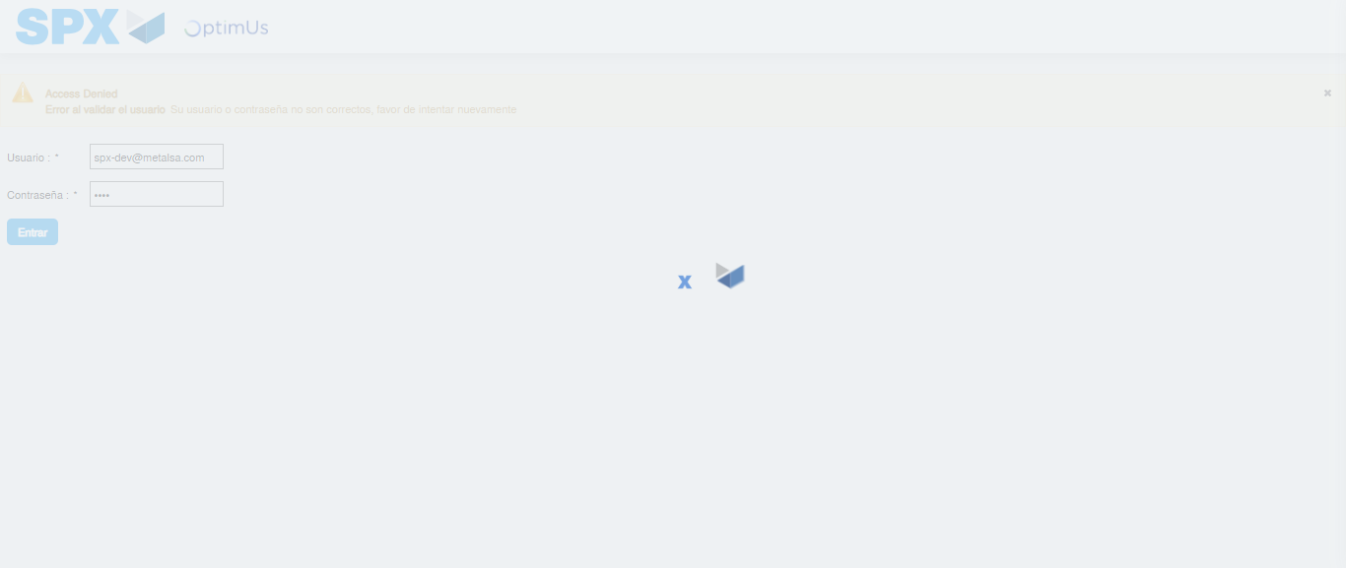Image file-name: QC_Testing-tc003_SPX_Dev5_Crear_Requisicion_Spot_Tipo_Cobro_CC_Urgent-1783358434228

Step 2 - Select to UEN and Access to Spot Buy Requisitions : UEN Correctly selected and Correct access
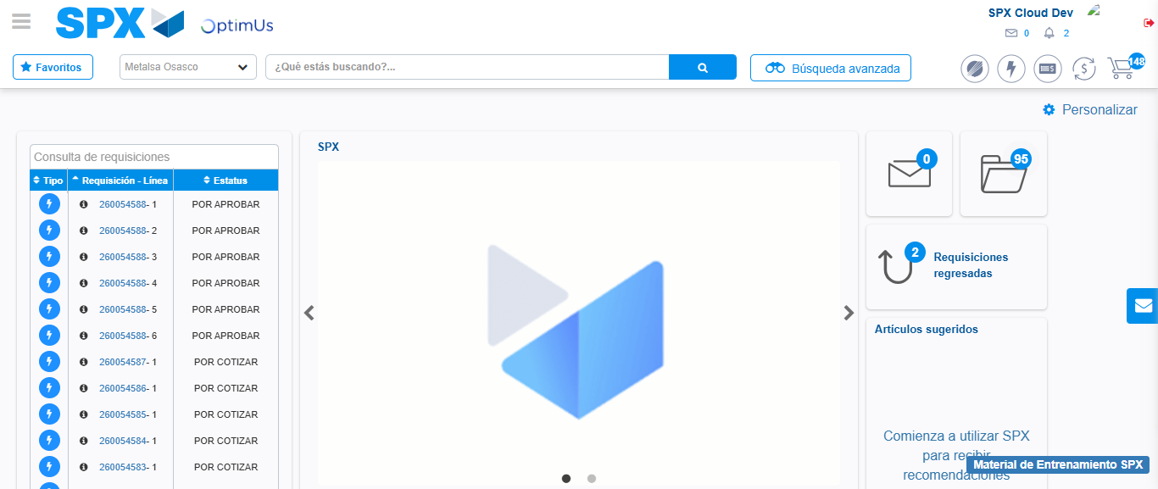Image file-name: QC_Testing-tc003_SPX_Dev5_Crear_Requisicion_Spot_Tipo_Cobro_CC_Urgent-1783358460623

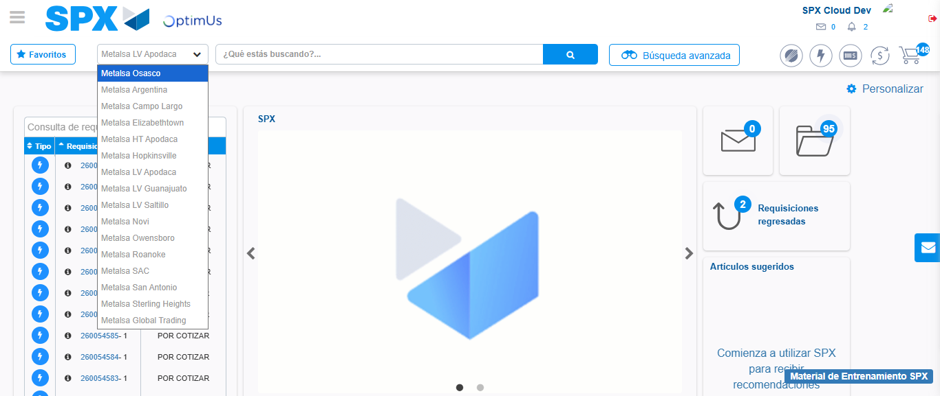Image file-name: QC_Testing-tc003_SPX_Dev5_Crear_Requisicion_Spot_Tipo_Cobro_CC_Urgent-1783358463553

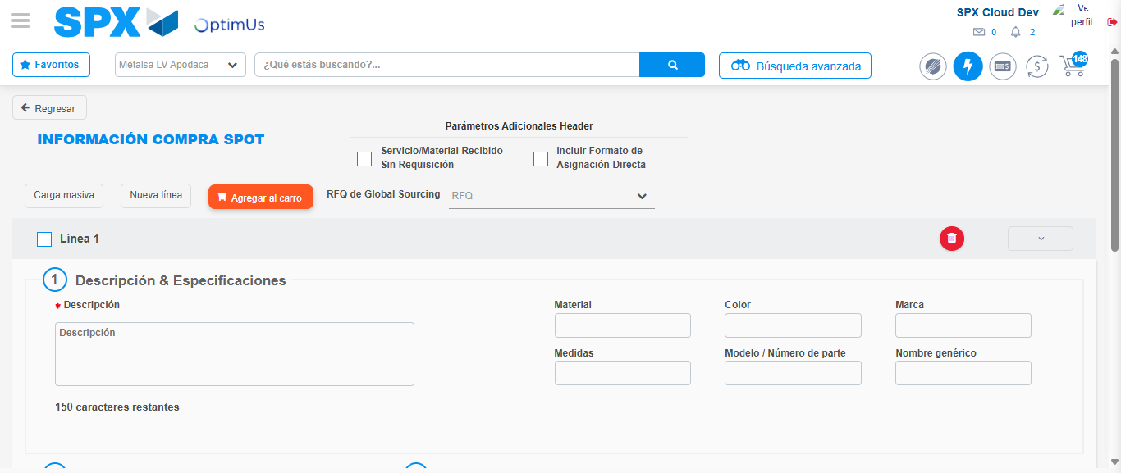Image file-name: QC_Testing-tc003_SPX_Dev5_Crear_Requisicion_Spot_Tipo_Cobro_CC_Urgent-1783358484735

Step 3 - Data Capture Spot Buy Requisition: Data captured correctly
Image file-name: QC_Testing-tc003_SPX_Dev5_Crear_Requisicion_Spot_Tipo_Cobro_CC_Urgent-1783358485054

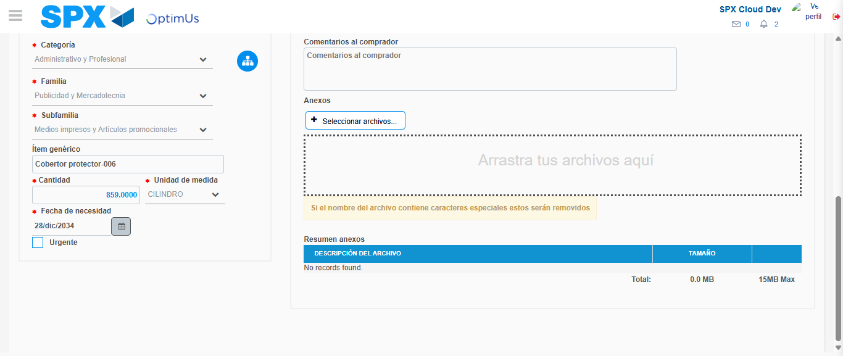Image file-name: QC_Testing-tc003_SPX_Dev5_Crear_Requisicion_Spot_Tipo_Cobro_CC_Urgent-1783358498254

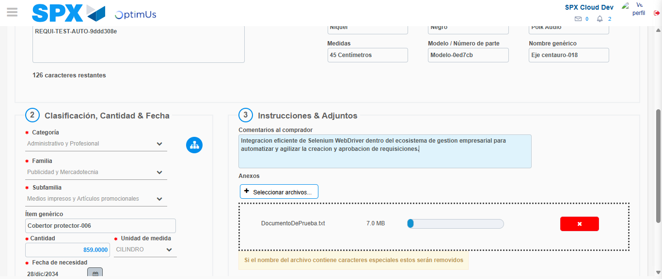Image file-name: QC_Testing-tc003_SPX_Dev5_Crear_Requisicion_Spot_Tipo_Cobro_CC_Urgent-1783358499243

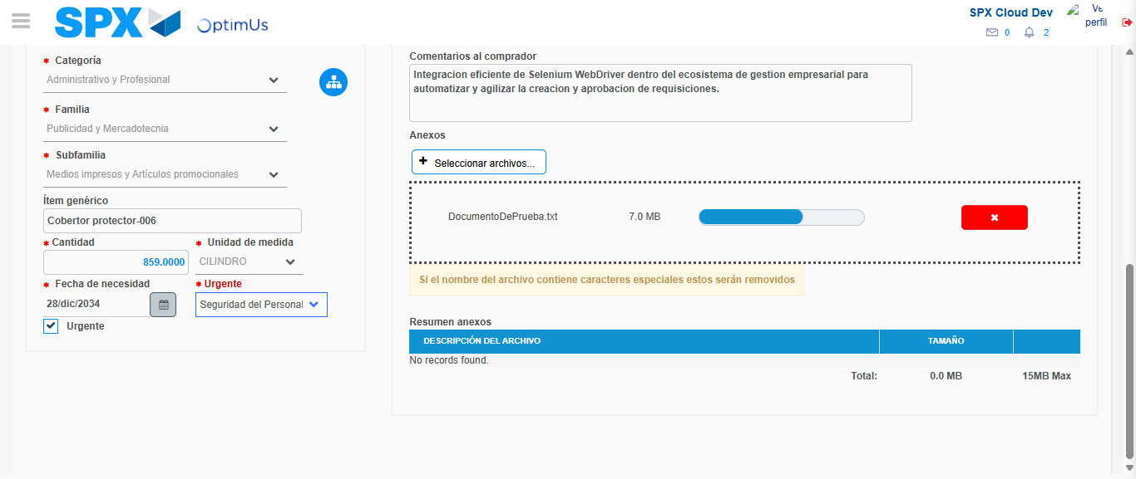Image file-name: QC_Testing-tc003_SPX_Dev5_Crear_Requisicion_Spot_Tipo_Cobro_CC_Urgent-1783358503171

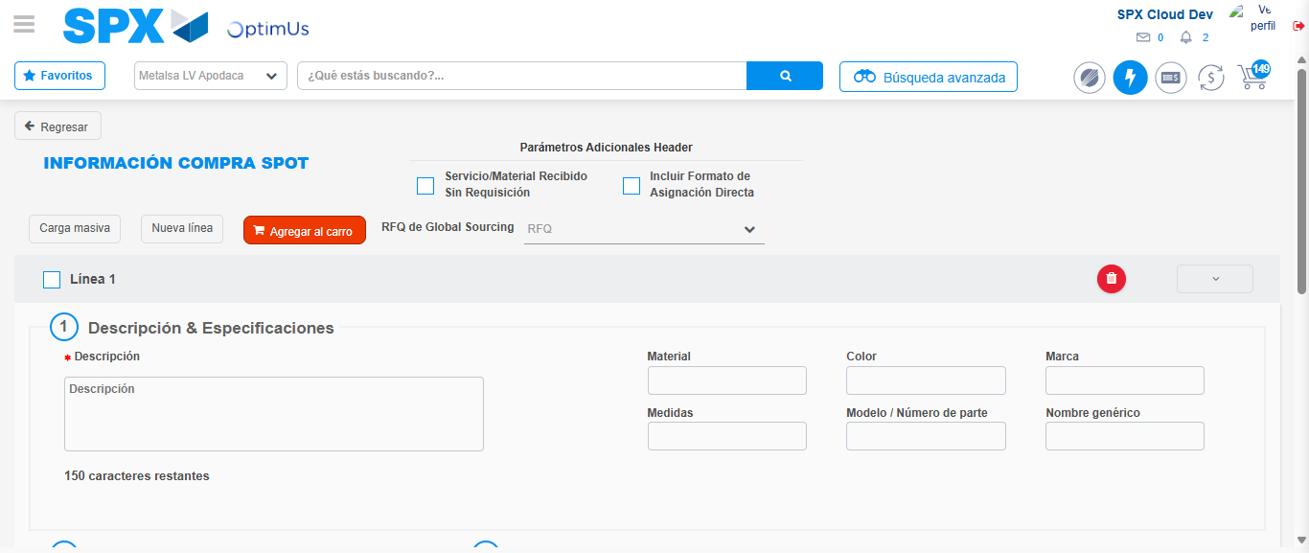Image file-name: QC_Testing-tc003_SPX_Dev5_Crear_Requisicion_Spot_Tipo_Cobro_CC_Urgent-1783358512995

Step 7 - Return to Main Page SPX : Return to Main Page SPX
Image file-name: QC_Testing-tc003_SPX_Dev5_Crear_Requisicion_Spot_Tipo_Cobro_CC_Urgent-1783358460623

Image file-name: QC_Testing-tc003_SPX_Dev5_Crear_Requisicion_Spot_Tipo_Cobro_CC_Urgent-1783358463553

Image file-name: QC_Testing-tc003_SPX_Dev5_Crear_Requisicion_Spot_Tipo_Cobro_CC_Urgent-1783358484735

Image file-name: QC_Testing-tc003_SPX_Dev5_Crear_Requisicion_Spot_Tipo_Cobro_CC_Urgent-1783358515332

Image file-name: QC_Testing-tc003_SPX_Dev5_Crear_Requisicion_Spot_Tipo_Cobro_CC_Urgent-1783358515503

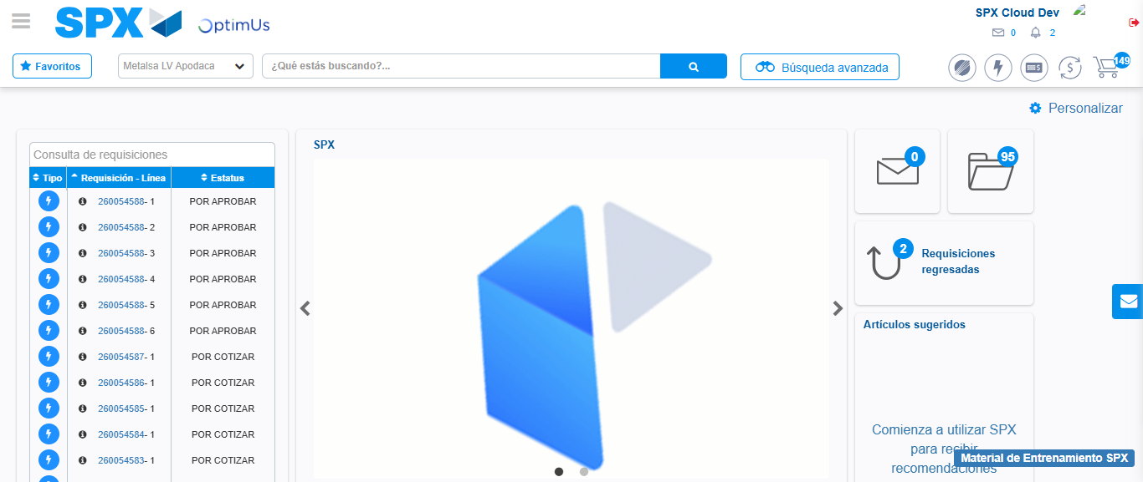Image file-name: QC_Testing-tc003_SPX_Dev5_Crear_Requisicion_Spot_Tipo_Cobro_CC_Urgent-1783358536894

Step 8 - Log Out : Log Out SPX
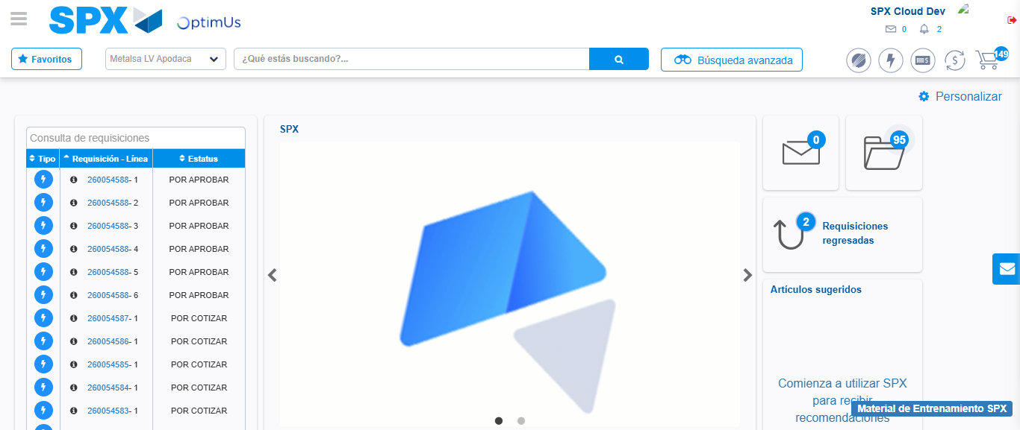Image file-name: QC_Testing-tc003_SPX_Dev5_Crear_Requisicion_Spot_Tipo_Cobro_CC_Urgent-1783358537240

